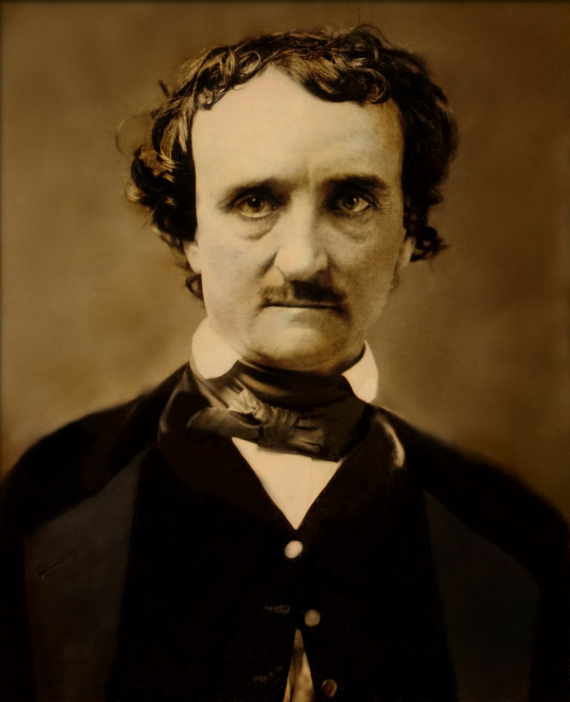

[Esta foto](https://longstreet.typepad.com/thesciencebookstore/2009/11/candidates-for-volumes-of-forgotten-lore-poes-nontitled-books-from-the-raven.html) de Autor desconocido está bajo licencia [CC BY-NC-ND](https://creativecommons.org/licenses/by-nc-nd/3.0/)

ProjectML

Marcella salas prado

# Summary

The website is inspired on a famous writer: Edgar Allan Poe. Here you will have access to reviews of his famous stories and poems. Also, a brief summary of the technique and legacy of Poe on the home page.

On his stories, you will have access to a youtube video about his famous tale: The Tell Tale Heart.

On his poems, a little review of which I consider his top 3 poems accompanied with an audio (Chopin, Nocturne).

# URL

<https://github.com/Marce740/proyect-first-term---dic>

# Screenshots

